**2. Hibernate and JDBC**

**Relationship between Hibernate and JDBC**:

Hibernate actually uses JDBC for all database communication. Hibernate is just another layer of extraction on top of JDBC. When our application using Hibernate framework, our app will store and retrieve objects using the hibernate API. Hibernate does all of the low level JDBC work and submitting the SQL queries and so on.

So Hibernate does a lot of the low level work for us but in the background, it all goes through the standard JDBC API.

When we actually configure Hibernate to talk to our database, we’ll actually configure Hibernate to make use of a JDBC driver.

Here is the key point is Hibernate using the JDBC API in the background for communication with the database.

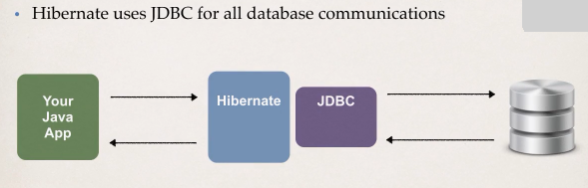

2. Hibernate and JDBC